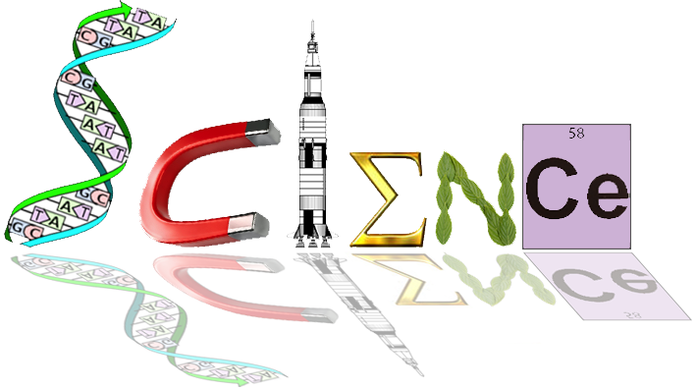


Year 12 ATAR Human Biology
The Immune Response
ATHBY Test 3 (Task 5) 2021
Total mark: ____ /63

MULTIPLE CHOICE SECTION 20 marks
Write answers on separate multiple choice answer sheet.

- Which of the following statements about bacteria is correct?
- Most bacteria have no ill effects on our health.
- It is unusual to have bacteria in or on the body.
- Bacteria can be identified by their location in the body.
- Bacteria cause diseases including influenza and warts.

- Viruses:
- cause diseases by secreting toxins from vesicles.
- can be identified using an ordinary light microscope.
- cause diseases by invading human cells.
- Cause diseases by amplifying genetic material.

- A disease that is normally present in a population (at a particular prevalence) is:
- pandemic.
- outbreak.
- endemic.
- epidemic.

- One example of a protective reflex that protects against infection is:
- acidic skin.
- cilia.
- flushing.
- sneezing.

- Phagocytes:
- make heparin.
- release histamines.
- can engulf and digest micro-organisms.
- secretes pus

- Inflammation:
- is decreased by histamines.
- only occurs in specific tissues or organs.
- is stimulated by mast cells.
- is stimulated by macrophages.

- The inflammatory response includes all of the following except:
- blood vessel constriction.
- temperature increase.
- increased blood flow.
- phagocyte attack.

- Fever can work to defend against pathogens by:
- inhibiting the growth of some pathogens.
- killing infected body cells.
- causing shivering.
- causing vasoconstriction restricting the movement of pathogens.

- Neutrophils and monocytes reach an infection site from the bloodstream because:
- the blood vessels rupture at a site of infection
- neutrophils and monocytes are amoeboid; they can squash against, and pass through, capillary walls.
- they are small and diffuse across membranes just like food and gas molecules.
- they move upstream in the lymphatic system

- Pus indicates that ______________.
- body tissues are dying.
- the body is trying to overcome infection.
- too much lymph has built up.
- the inflammatory response has failed to defend against bacterial invasion.

- Mechanical barriers, such as surgical masks, work to reduce transmission of pathogens by:
- killing pathogens before they enter the body.
- providing an obstacle to pathogens entering the body.
- washing away pathogens.
- reducing inflammation.

- Which type of immunity is demonstrated when a mother’s antibodies transfer to a
baby via the placenta or breast milk?
- Natural, passive immunity.
- Artificial, passive immunity.
- Natural, active immunity.
- Artificial, active immunity.

- The advantage of naturally acquired, active immunity is that:
- it is usually long lasting, sometimes for life.
- it can develop without exposure to an antigen.
- it produces antibodies against a wide range of infective agents.
- it immediately provides high levels of antibodies upon first exposure.

- Various surgical treatments for breast cancer require the removal of some or all of the lymph nodes in the axilla (armpit). This would likely result in:
- improved ability of the body to fight infection.
- reduced spread of communicable pathogens around the body.
- reduced volume of lymph.
- swelling (oedema) of the arm where lymph nodes were removed.

- Identify the incorrect statement below.
- T cells form in the bone marrow but mature in the thymus.
- Monocytes give rise to macrophages, which are involved in both specific and non-specific responses.
- Eosinophils are involved in anti-parasitic and bactericidal activity.
- B cells trigger the inflammatory response.

- Antigen presenting cells (APCs):
- can be macrophages.
- help B cells recognize a specific antigen.
- are types of antigens.
- are types of receptors on B and T cells.

- Antibiotics are often ineffective against viruses because viruses:
- keep changing their external protein coat.
- are able to disguise themselves in the host cell membrane.
- are not true living cells, so their metabolism is not affected by antibiotics.
- can destroy or inhibit the actions of antibiotics in living cells.

- When a person is exposed to a disease for which they have been vaccinated, it is likely:
- they will never come in contact with the disease agent.
- they will show immediate symptoms of the disease.
- they will fight off the disease quickly.
- they will die.

- Tony cut his foot on a piece of rusty metal and had to go to the doctor to have stitches.
The doctor also gave him an injection to prevent him from contracting tetanus.
The immunity that Tony gained from having the injection was
a. passive and artificially acquired.
b. passive and naturally acquired.
c. active and naturally acquired.
d. active and artificially acquired.

- Antibodies are passed from mother to baby through the placenta during the third trimester.
This gives the baby some protection when they are born. Identify the correct statement below.

- Antibodies produced in the mother’s body are passed to the infant via passive immunity
through breast milk.
- Antibodies produced in the mother’s body are passed to the infant via active immunity
through breast milk.
- Antibodies produced in the mother’s body are passed to the infant via passive immunity
through experiencing the same environment.
- Antibodies produced in the infant’s body are passed to the mother via active immunity
through the placenta.
SHORT ANSWER SECTION 33 marks

- Name the three types of T-lymphocytes and describe the role each play. (6 marks)

Description  Any 3 cell types with matching roles | Marks
Cytotoxic T cells  attacks cells with foreign antigens directly and destroy them | 1  1
Helper T cells  assist in the activation of B cells and killer T cells /  enhance ability of macrophages to engulf and destroy microorganisms / attract white blood cells | 1  1
Memory T cells  able to recognise the original invading antigen, allow a fast response if antigen reinvades | 1  1
Suppressor (Regulatory) T cells  suppress the activity of B cells and T cells so antigen is tolerated /  switch off immune response once antigens have been destroyed | 1  1

- Antibiotics revolutionised the treatment of infections.

a. Identify the two key types of antibiotics and explain how they work. (4 marks)

Description | Marks
Bacteriostatic antibiotics | 1
inhibit bacteria growth /  interfere with protein synthesis allowing the immune system to overcome the infection | 1
Bactericidal antibiotics | 1
destroy bacterial pathogen by targeting outer cell walls, inner cell membranes or metabolism pathways of bacteria | 1

b. Antibiotic resistance threatens the effective prevention and treatment of an ever-increasing range of bacterial infections. Suggest two factors that contribute to antibiotic resistance and two strategies to address this issue. (4 marks)

Description  Any 4 of the options below | Marks
Overuse of antibiotics in treatment of diseases | 1
Overuse of antibiotics in food-producing animals | 1
People stop taking antibiotics when symptoms disappear | 1
Antibacterial ingredients in cleaning agents favour the survival of antibiotic resistant strains of bacteria | 1
Only take antibiotics when they are prescribed for you | 1
Use prescribed antibiotics as advised by health professionals | 1

Note: https://www.amr.gov.au/about-amr/how-does-amr-spread

c. State one reason why antivirals are more difficult to develop than antibiotics. (1 mark)

Description  Any 1 of the following options | Marks
Resistance due to rapid mutation | 1
Labour intensive and expensive | 1
Viruses are intracellular parasites make targeting more difficult to avoid host toxicity | 1

23. Agglutination occurs as a result of the interaction between antibodies and a particulate antigen.

a. Describe three other ways in which antibodies can act on pathogens to help fight infection. (3 marks)

Description  Any 3 of the following | Marks
combine with foreign bacterial toxins | 1
Inactivate/neutralise/produce toxins | 1
binds to surface of viruses | 1
enhance phagocytosis | 1
prevent viruses from uncoating to release viral genome in host cells | 1

b. Name the type of lymphocyte responsible for the production of antibodies. (1 mark)
Description | Marks
B cells/ B lymphocytes/ plasma cells | 1

- The graph below shows the immune response of two people, one of whom has been vaccinated against a disease and the other not.

.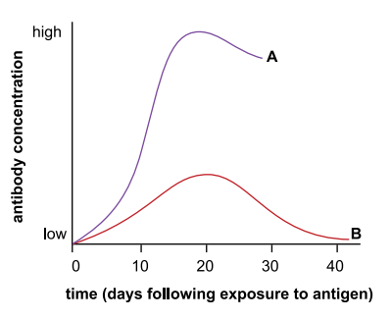
- Identify the person (A or B) who has been vaccinated and explain your answer. (2 marks)

Description | Marks
Person A | 1
Initiates secondary antibody response | 1

- In the later stages of the infection, a person infected with HIV would show a different pattern to either of these curves. Describe and account for this difference. (2 marks)

Description  Any 1 of the following options | Marks
HIV invades immune cells | 1
Cytokines released is reduced | 1
Reduce activation B cells | 1
Less antibodies produced | 1

- Protection against influenza generally requires one dose of Fluvax vaccine.
Sometimes, a follow up (booster) dose may also be given. Explain why some vaccines need boosters and why they have a specific schedule. (2 marks)

Description  Any 2 of the following options | Marks
Immunity against a particular pathogen has a tendency to wear off over time | 1
Booster is given to lengthen the duration of immunity | 1
The body may not have produced sufficient antibodies on initial dose | 1
Insufficient antibodies produced | 1
To ensure that a sufficient supply of antibodies that react against a potential infectious agent or toxin are present in the body before infection occurs | 1
To ensure that a sufficient supply of T and B cells that react against a potential infectious agent or toxin are present in the body before infection occurs | 1

EXTENDED ANSWER SECTION 10 marks
- Kidney infection (pyelonephritis) is most commonly caused by Escherichia coli bacteria.
If a person is infected with Escherichia coli, antibodies are produced to fight the infection.

a. Outline the immune response that produces antibodies (6 marks)
Description | Marks
Humoral immune response involves mainly B cells and takes place in blood and lymph | 1
B cell activation/ antigen binds to native B cell receptor | 1
Activated B cell/ macrophages engulfs antigen and digest it | 1
Antigen fragments bound to MHC molecule | 1
Antigen presentation attracts mature T cell | 1
Cytokines secreted by the T cell | 1
B cell proliferation/ differentiation of activated B cells | 1
Produce plasma cells and memory cells | 1
Plasma cells produce antibodies and release into blood stream | 1

https://bio.libretexts.org/Bookshelves/Introductory_and_General_Biology/Book%3A_Introductory_Biology_(CK-12)/13%3A_Human_Biology/13.50%3A_Humoral_Immune_Response

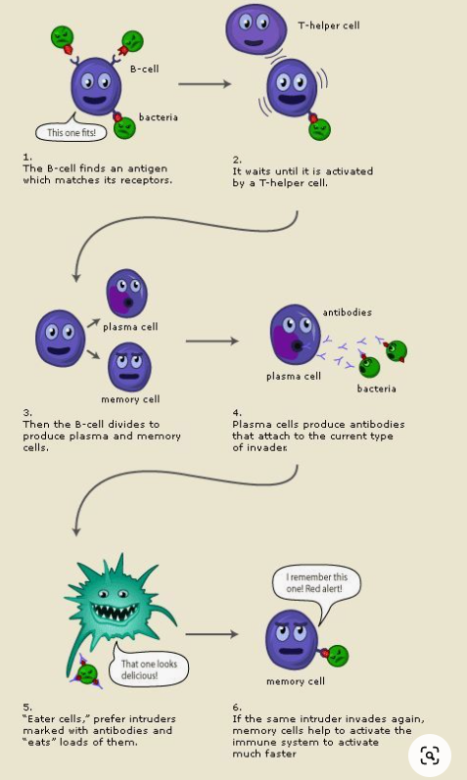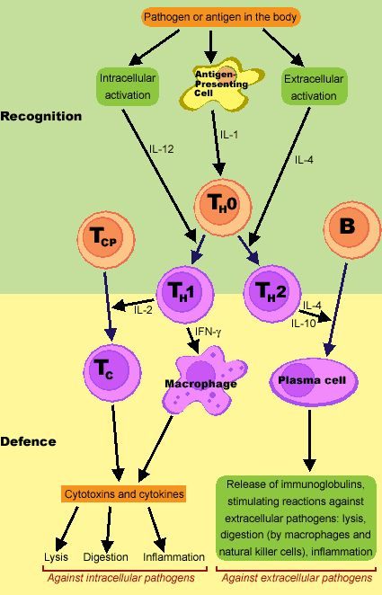

Unfortunately, an untreated renal infection can progress into renal failure. A transplant is a treatment for end stage kidney disease but is not a cure. A child with a defective kidney received a new kidney transplant from a non-related male. This patient failed to take the appropriate medication and the transplant was rejected.

b. Describe the cell-mediated immune response that resulted in the rejection of the transplanted kidney.
(4 marks)

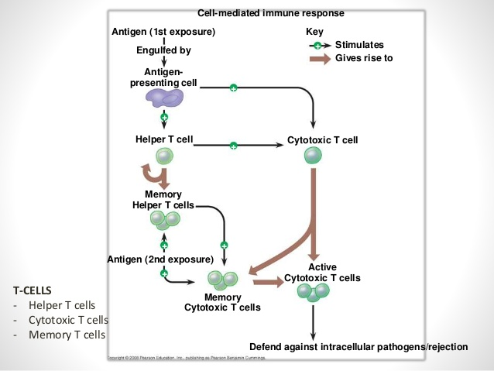

Description  Any 2 of the options below | Marks
The antigen for the pathogen is taken up by an antigen-presenting cell (APC), such as a dendritic cell or macrophage, through phagocytosis | 1
The APC travels to a part of the body that contains immature T and B cells, such as a lymph node | 1
The antigen is presented to immature helper T cells and cytotoxic T cells through binding the MHC II (helper T) or MHC I (cytotoxic T) to T-cell receptors | 1
These T lymphocytes mature and proliferate. Helper T cells activate B cells, which proliferate and produce antibodies specific to the antigen, while cytotoxic T cells destroy pathogens that bear the antigen that was presented to them by the APCs | 1
Memory B and T cells are formed after the infection ends | 1

Description  Any 2 of the options below | Marks
T cells recognise donor tissue as a non-self-antigen | 1
T cell mediated response against foreign MHC from donated organ | 1
T-cells release toxins that induce cell apoptosis | 1
Natural killer cells promote tissue rejection by releasing cytokines | 1
Cytokine profile activates macrophages, natural killer cells and cytotoxic T cells that are drawn to the tissue graft | 1
Activation of B cells for antibody production towards the graft | 1
B cells develop into memory cells and return to the bone marrow, developing an immunological memory towards the graft | 1

